|  |
| --- |
| University of Canterbury |
| Generating Power for Remote Applications in Extreme Environments |
| ENEL427 |
|  |
| **Nathan M. Rich** |
| **/2011** |

|  |
| --- |
| [Type the abstract of the document here. The abstract is typically a short summary of the contents of the document. Type the abstract of the document here. The abstract is typically a short summary of the contents of the document.] |

# Abstract

This document provides a template and guidelines for students preparing final project reports for the Third Professional Year Project. Instructions within this document should be adhered to closely. *Excluding title page, abstract page, references and any appendices*, the maximum page limit is **15 pages**. This limit may not be exceeded. Appendices are for additional background material and are **NOT** to be used as a place to extend the report and avoid the page limit. A penalty schedule applies for reports which do not fall within the guidelines as presented in this paper.

The abstract must be placed on its own page, which should be numbered page 1 at the bottom centre of the page. The abstract is limited to 250 words, but should be at least 50 words in length. No table of contents is needed, nor should one be included. Begin the introduction on page 2.

Table of Contents

Abstract 1

1. INTRODUCTION 3

2. CHOICE OF POWER GENERATION 3

2.1 Pressure 3

2.2 Temperature 3

2.3 Chemical 4

2.4 Kinetic 4

2.5 Decision 4

3. THEORY OF OPERATION 4

3.1 Overview 4

3.2 Simplifications 4

3.3 Turbine 4

3.4 Gearbox 5

3.5 Generator 5

3.6 Power Converter 5

3.7 Battery Pack 5

3.8 Output Motor 6

3.9 Wheels 6

3.10 Undersea Challenges 6

3.11 Conceptual Design 6

4. COST/CONSTRUCTION 7

5. TESTING 7

6. DISCUSSION 8

7. REFERENCES 10

# INTRODUCTION

Around the world there are many extreme environments in which conventional battery power is not suitable for powering devices due to the fact that one has to replace the battery when it runs out and the environment does not easily allow this. Getting rid of conventional battery power essentially means creating a self-powered device.

The environments can have temperatures from -30 to 2000 ̊C with extremely high or low pressures. To build a device that can generate power for some application and withstand the environment is the challenge of this project. Of benefit is the environment itself as high temperatures and pressures can be used to generate power because there is an abundance of it in the extreme environment.

In this project the extreme environment chosen is the sea environment. In the sea the temperature can range from 3 to 21 ̊C and the pressure increases 1 atmosphere per 10 metres of depth under water (Zabel, 2006). Thus the solution must be able to handle these temperatures and generate power.

The specific tasks of this project are to investigate an extreme environment finding a suitable way to power a device and then to design a solution. The goal upon completion is to have a well thought out design that could be built and used in the real world.

As an example of the possible applications of such a device is a small robot that crawls along the ocean floor either videoing what it finds or testing ocean floor sediments.

# CHOICE OF POWER GENERATION

Given that the extreme environment was the sea the first task was to choose a method of power generation. Research was done via the internet looking into the characteristics of the sea and trying to identify ways to exploit the environmental characteristics, see appendix 1. Four different possible ways of generating power in the sea were considered and the following information was found.

### Pressure

High pressure is one of the extreme environmental elements of the sea for which this project was chosen. Thus it makes sense to try exploit this characteristic as there is virtually no limit to its supply. In exploiting it one would also have to think of any environmental impacts it might have.

From the research done it was found that to create energy from pressure one must obtain a differential however small. In the sea environment there is high pressure but it is not a differential. There were two ways that were thought of to obtain a differential; the first was by having to devices with one much deeper than the other as it is known that the pressure increases the deeper down one is. Thus the two devices have different pressures and a differential is found. The disadvantage to this though is that the whole solution would have to be rather large and would therefore not be very helpful on moving objects and would be more prone to damage from sea creatures. The second way that was thought of to create a differential was to use the undersea currents which would press against a plate creating a differential. This technology is in fact already been in use in the form of hydrophones (Wilson, 2005) and uses piezoelectric technology.

### Temperature

A low temperature is the other environmental extreme of the sea and so it makes sense also to try exploiting this. However as with pressure a differential in temperature is needed. The only way hypothesized to create such a differential was to once again have two devices at different depths so that different temperatures are found. However since this is the same solution as before it has the same disadvantages.

### Chemical

### Kinetic

The solution of using the pressure of currents to create a pressure differential was the best solution found thus far however glaring problem was that the current would push the device very heavily when contacting the plate. Another solution that solves this problem is actually a lot simpler than the piezoelectric technology although not as exciting; a turbine. Using a turbine would allow water to flow through the device generating the power but not being pushed as much by the current.

### Decision

Given the options above, the method of power generation was decided to be kinetic utilizing a turbine to harness the power of undersea currents.

# THEORY OF OPERATION

### Overview

A relatively simple design has been produced and a block diagram of it is shown in Fig 1.



Figure 1. System Block Diagram

### Simplifications

In order to create a robot design in the space of time given it was decided to make simplifications to the robot design that could be rectified in the future once the initial design was proven. For example the robot design given gives no ability to turn or maneuvre around difficult obstacles. The robot also has remote control feature. That is the robot simply moves forward when given power and waits otherwise. The robot also does not have the features that would make it useful such as sediment testing facilities or an onboard video camera, these features were intended to be added once the robot has proven the ability to harvest and put to use power from passing currents.

### Turbine

In order to harness the power of the passing currents a turbine is attached to the top of a small robot. As a starting point this turbine will be in a fixed position, that is, it will not be able to rotate in order to maximize the power. The size of the turbine is governed by the amount of power required. The output motor chosen to power the wheels of the robot requires 5V and 1A when running and there shall be two motors; one powering the back wheels and one powering the front wheels. This means that a total of 10W of power will be required at the output not including any extra features the robot might incorporate. Assuming other features might need up to 10W, the total output power becomes 20W, finally assuming the power converter to be about 80% efficient the input power will need to be at least 25W.

Using the following equation for power from a water turbine (Kirke, 2005):

The efficiency of the turbine is assumed to be = 0.3 given the Betz Limit of 0.6 and the density of water to be 1024kg/m3 (Polagye, 2009).

V is velocity, about 3 knots = 1.54 m/s (Statnikov, 2002)

Therefore the diameter of the turbine needs to be at least 16.8 cm.

### Gearbox

Since the

### Generator

The generator chosen was the Scorpion S-4025-16, which is a 3 phase delta wound motor (Scorpion, 2011). The motor was said to work at 17.5V and have a continuous output of 2 kW; however when tested as a generator these figures were found to be around 9V with a continuous output of only 30W as shown in the testing section of this report. This generator was chosen not for optimization of design but for optimization of cost as the generator was already in the department and hence could be used free of charge.

### Power Converter

The power converter takes the power from the generator and transforms it into an output suitable for the wheel motors. The power converter must convert the 5V, 1A AC wave into a 5V, 2A DC waveform. Many power converter solutions are available so it is important to look at characteristics that will narrow the selection. As the only outputs are the two motors no isolation is required, and thus a three phase rectifier bridge consisting primarily of 6 diodes is used to transform the 3 phase AC to single phase DC. A small amount of DC bus capacitance is then required to filter the wave. After that a buck-boost DC-DC converter will be used to step up or down the voltage depending on the voltage at the time.

### Battery Pack

### Output Motor

The output motor aims to take the power from the power converter and use it to power the wheels which give the robot the ability to move. The motor chosen, like the generator, was chosen as available on hand. It has 5V and 1A running characteristics. In order to give the robot traction in most situations the robots shall be four wheel drive and hence two identical output motors shall be put in parallel, one for the front wheels and one for the back. Having the motors in parallel will also decrease the resistance seen by the generator which will increase the power output as seen in the testing section of this report.

### Wheels

In order to get traction in the soft undersea sediment, large spiked wheels with attached tank tracks have been chosen. The use of tank tracks will also distribute the weight of the robot over a large area to reduce the chances of sinking.

### Undersea Challenges

Given that water conducts electricity is it imperative that no water can get into the electronics of the robot. This means that the robot must be completely water tight. However at deep sea the atmospheric pressure has increased 1 atmosphere for every 10 m underwater. This means that if the robot is filled with air it is likely to be crushed as air compresses under pressure. For this reason the robot should be filled with an incompressible liquid that is also non-conducting. Oil is a perfect choice as it fulfills both these requirements and is relatively easy to obtain. In terms of building this means that the robot should be submerged in an oil bath as the casing is sealed. In this way the robot can be sure to have no air in it.

### Conceptual Design

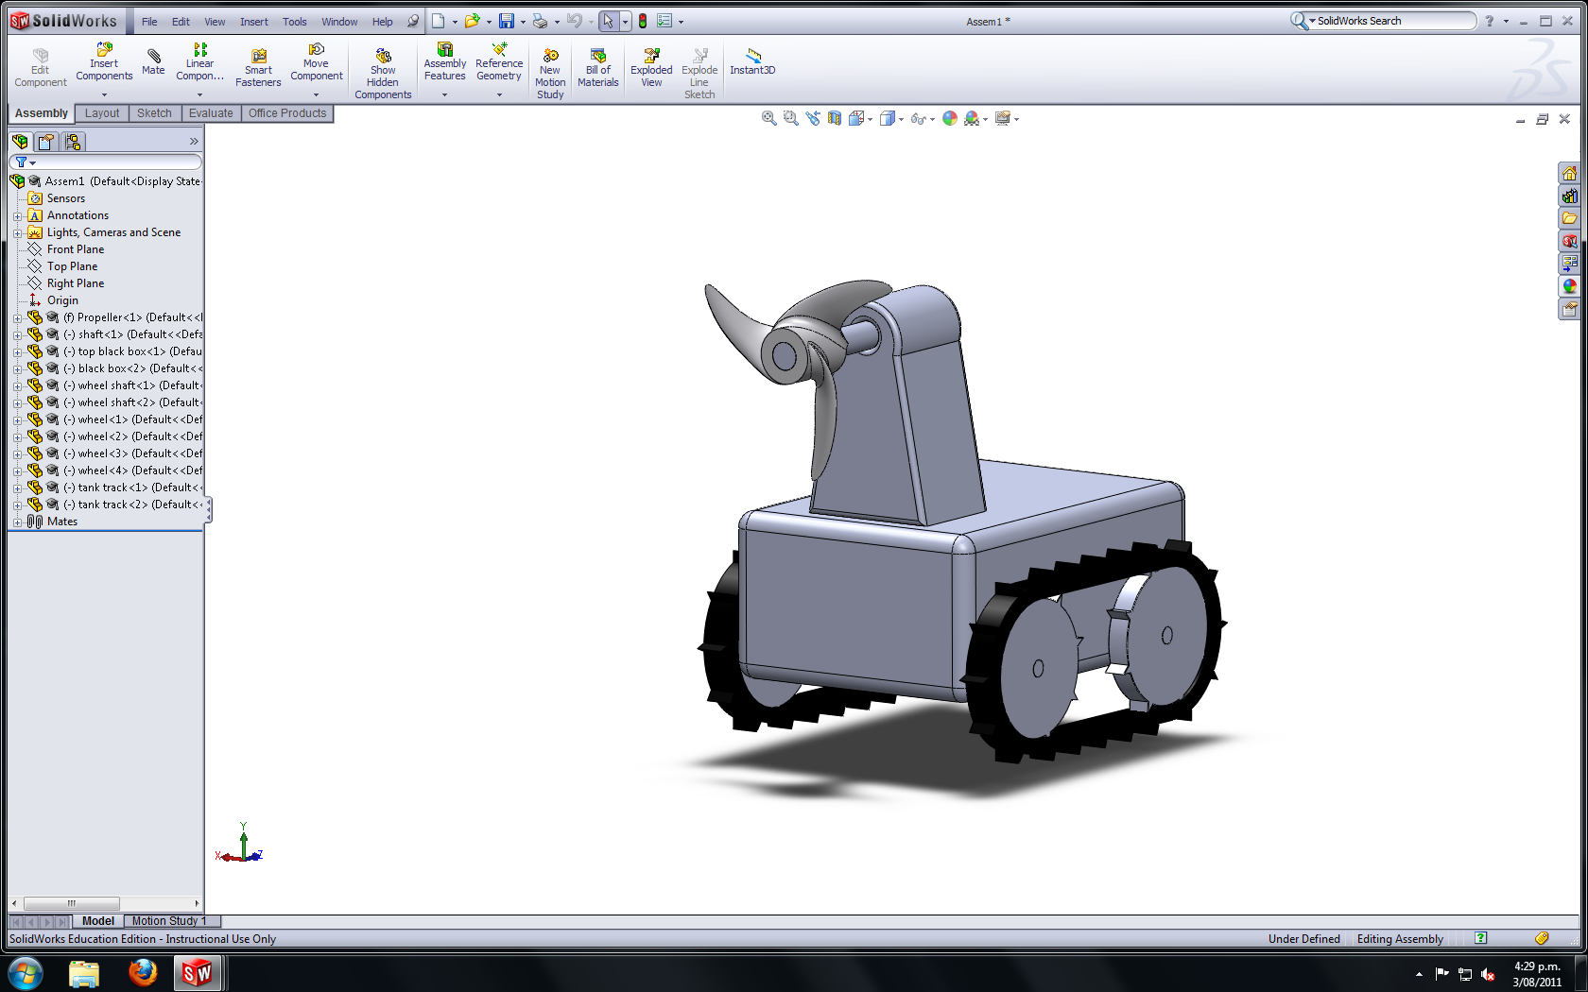

# COST/CONSTRUCTION

|  |  |
| --- | --- |
| Item | Cost |
| Generator | Free |
| Motor (x2) | $30 |
| Turbine | $5 |
| Tank tracks and wheels | $10 |
| Enclosure | $20 |
| Oil | $10 |
| Total |  |

To avoid rust, the robot will be made of plastic wherever possible. That is the enclosure, turbine, wheels and tank tracks will all be plastic. This leaves the only metal parts to be the generator, the motors, and the power converter; however these components will be enclosed in oil and as such should not be at risk of rust.

In building the robot extreme care must be taken when sealing the oil filled enclosure. To ensure no air bubbles it is envisioned that the sealing of the enclosure will be done in an oil filled tub.

# TESTING

Before building electrical devices, the testing of key components must occur. In this case the key component is the generator as the characteristics of it will determine the specifics of the power converter part of the design. To determine the characteristics of the generator, the generator was set up with a variable resistive load attached to each phase and the voltage and current were measured through one phase. The generator was then spun using a mechanically attach dynamometer as shown in. The following measurements were taken and then graphed in Fig 2.

|  |  |  |
| --- | --- | --- |
| Per Phase Resistance 5Ω |  |  |
| Speed | Current (A) | Voltage (V) |
| 0 | 0 | 0 |
| 200 | 0.046 | 0.311 |
| 400 | 0.084 | 0.520 |
| 600 | 0.114 | 0.752 |
| 800 | 0.142 | 0.991 |
| 1000 | 0.170 | 1.256 |
| 1200 | 0.193 | 1.486 |
| 1400 | 0.214 | 1.726 |
| 1600 | 0.236 | 1.970 |
| 1800 | 0.255 | 2.209 |
| 2000 | 0.275 | 2.462 |
| 2200 | 0.292 | 2.698 |
| 2400 | 0.308 | 2.929 |
| 2600 | 0.323 | 3.167 |
| 2800 | 0.337 | 3.408 |
| 3000 | 0.351 | 3.636 |
| 3200 | 0.363 | 3.856 |
| 3400 | 0.376 | 4.105 |
| 3600 | 0.387 | 4.334 |
| 3800 | 0.397 | 4.540 |
| 4000 | 0.408 | 4.764 |

|  |  |  |
| --- | --- | --- |
| Per Phase Resistance 1Ω |  |  |
| Speed | Current (A) | Voltage (V) |
| 0 | 0 | 0 |
| 200 | 0.22 | 0.293 |
| 400 | 0.444 | 0.501 |
| 600 | 0.665 | 0.734 |
| 800 | 0.862 | 0.963 |
| 1000 | 1.060 | 1.200 |
| 1200 | 1.249 | 1.439 |
| 1400 | 1.422 | 1.660 |
| 1600 | 1.599 | 1.903 |
| 1800 | 1.762 | 2.139 |
| 2000 | 1.922 | 2.375 |
| 2200 | 2.075 | 2.609 |
| 2400 | 2.215 | 2.850 |
| 2600 | 2.365 | 3.100 |
| 2800 | 2.496 | 3.339 |
| 3000 | 2.619 | 3.560 |
| 3200 | 2.750 | 3.817 |
| 3400 | 2.860 | 4.044 |
| 3600 | 2.986 | 4.307 |
| 3800 | 3.093 | 4.542 |
| 4000 | 3.189 | 4.763 |

|  |  |  |  |
| --- | --- | --- | --- |
| Per Phase Resistance 0.5Ω | |  |  |
| Speed | Current (A) | | Voltage (V) |
| 0 | 0 | | 0 |
| 200 | 0.389 | | 0.200 |
| 400 | 0.795 | | 0.423 |
| 600 | 1.186 | | 0.645 |
| 800 | 1.579 | | 0.869 |
| 1000 | 1.970 | | 1.098 |
| 1200 | 2.353 | | 1.333 |
| 1400 | 2.708 | | 1.551 |
| 1600 | 3.060 | | 1.771 |
| 1800 | 3.418 | | 2.002 |
| 2000 | 3.759 | | 2.226 |
| 2200 | 4.092 | | 2.448 |
| 2400 | 4.460 | | 2.688 |
| 2600 | 4.780 | | 2.912 |
| 2800 | 5.100 | | 3.140 |
| 3000 | 5.410 | | 3.360 |
| 3200 | 5.720 | | 3.580 |
| 3400 | 6.000 | | 3.808 |
| 3600 | 6.280 | | 4.018 |
| 3800 | 6.560 | | 4.240 |
| 4000 | 6.840 | | 4.438 |

Figure 2. Plot depicting the relationship between current and voltage for the generator depending the resistance per phase.

* 1. **References**

An example reference style is provided in Section 5 [1]. References should be numbered in the order called out in the report and referred to in brackets as illustrated [2]. Any work referred to must be included in the references [3]. Any source consulted for your project must be disclosed. Failure to do so may result in a failing grade.

* 1. **Figures**

Figures should be numbered consecutively, include a figure caption, and be placed as close to the referring text as possible (Fig. 1). Figure headings/titles are only appropriate in PowerPoint presentations. Tables do not have captions; rather, each table has a number and a heading.

**2.5 Penalties (Maximum possible score is 100 marks)**

The following penalties can be assessed against any report failing to keep to within guidelines:

1. Exceeding page limit 10 marks/page

2. Not meeting margins, page size, or font size limits 50 marks

# DISCUSSION

### Generator Results

From Table 1 it is clear that the generator produces more current for a smaller resistance and given that power is given by , the smaller the resistance, the more current and more power. This means it is a much better idea to parallel the two output motors rather than have them in series as it will decrease the overall resistance and hence increase the power.

Given the results of the generator we can see that the output power ranges from 0 to 70W for resistance of 0.5 - 5Ω and speeds of 0 – 4000rpm. This is well above the required 25W, and hence the generator need only spin at around 1000rpm for a resistance per phase of 0.5Ω.

### Future Steps

So far only the generator has been tested while the motor and power converter have yet to chosen, the next step would be to choose a motor and find the characteristics of it and then find a power converter to match.

Following this the robot enclosure would need to be built to find the loading on the motor.

A well-written report has several key characteristics. First, the abstract is written for the person who has no time or inclination to read the remainder of the report. The key points as well as a brief overview must be conveyed in a relatively small number of lines. The introduction should not include a cut-and-paste version of the abstract, but neither should the writer assume the reader of the introduction has bothered to read the abstract. In many ways, they are two separate documents.

The examiners will expect a good overview of your project, beginning with appropriate background material. Do not assume the reader is an expert in the narrow field of your work, but do assume the reader is an electrical engineer by training. Acronyms should be spelled out at their first usage. After reading the introduction, the reader should be left with an understanding of the scope of your project as well as its motivation.



Figure 1 Plot depicting relationship between maximum possible grade and adherence to report guidelines.

The theory section of your report is important, but no more than perhaps 3 to 5 pages should be dedicated to it as a general rule. Examiners will expect a reasonable depth of development for whatever theory or principles you describe. Equations, schematics, and diagrams should be used as required. In some cases, it will seem more natural to include the theory behind your *basic* approach in this section, and then discuss the detailed operation of your final design in the Discussion section.

The most important section of your report is a discussion of results. This includes measured performance of your project, testing results, and data collected. A well-thought-out discussion relates these factors to the theory upon which you based your work. If several iterations were required, the thinking behind each stage or phase of the project is appropriate to describe.

Finally, a few words regarding writing style are warranted. Unlike this template document, a good paragraph typically has 5 to 8 sentences. Longer paragraphs are probably too diverse in their focus, and shorter paragraphs represent fragmented topical development. Punctuation and spelling should be carefully checked, and it is good practice to print out the PDF document prior to emailing in order to proof check formatting.

**4. CONCLUSIONS**

The conclusions section should not merely represent a summary of the report, although a brief summary is permissible as one component. Under no circumstances should nonsense statements such as “I learned a lot” or “I really enjoyed this project” be included. Written by an engineer, the report should reflect careful thinking and a measurable degree of professionalism. Conclusions regarding the suitability of the approach chosen, the quality of the data collected, the performance of the final product and any possible future directions the project can be taken should be included.

**5. REFERENCES**

[1] P.Q. Smith, A Handy Solution, **3rd Professional Year Project Report**. Christchurch, New Zealand, 1895.

[2] Y.Q. Smith, “A simple circuit for all applications,” IEEE Transactions on Ohm’s Law **45**, 1932, 980-987.

[3] I.Q. Smith, “Your Third Pro Project,” Reports-for-free.com, 2005.

[4] J. Smith, “How to cite the world wide web,” [www.citethis.com](http://www.citethis.com/), accessed 2 Feb 2006.

# REFERENCES

Kirke, B. (2005). Retrieved 2011, from Cyberiad: http://www.cyberiad.net/library/pdf/bk_tidal_paper25apr06.pdf

Polagye, B. L. (2009). *Hydrodynamic effects of kinetic power extraction by in-stream tidal turbines.* University of Washington.

Scorpion, P. S. (2011). *Scorpion S-4025-16*. Retrieved July 2011, from Scorpion Power Systems: http://www.scorpionsystem.com/catalog/motors/s40/S-4025-16/

Statnikov, E. (2002). *Speed of Ocean Currents*. Retrieved July 2011, from The Physics Factbook: http://hypertextbook.com/facts/2002/EugeneStatnikov.shtml

Wilson, J. S. (2005). *Sensor Technology Handbook (Vol 1).* Newnes.

Zabel, M. (2006). *Marine Geochemistry.* Birkhauser.

**APPENDIX (OR APPENDICES)**

Appendices may include tables of data, source code, procedures or other information suggested or required by the project supervisor. Its presence will be noted by the examiners, but the content will not be graded.